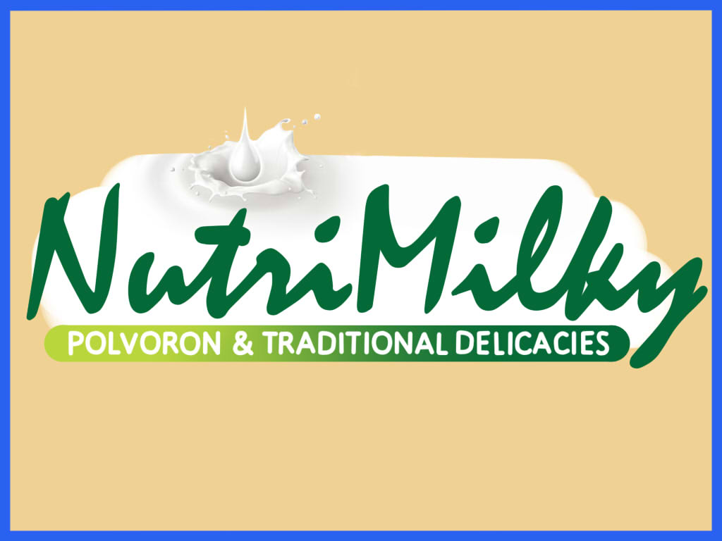

- Introduction

The project NutriMilky promotes the Filipino traditional delicacies and a dessert and makes it tastier. The NutriMilky Company makes products to another taste and nutritious delicacies. This project gives a special taste to the persons who love to eat sweet foods and it can give vitamins also. The company is created because the products are easy to create and you can buy it in a cheap price in the public markets, local markets, stores, and other food courts. Our goal is to create good desserts like polvoron, pastillas and yema. But the NutriMilky produce more in polvoron production because of its sweet taste and you can enjoy its different kind of its flavors.

The NutriMilky Polvoron gives another taste and contains malunggay to become more nutritious. The NutriMilky polvoron malunggay flavor is our special polvoron because for every pound of malunggay has seven times more Vitamin C than oranges, three times more potassium that bananas, four times more Vitamin A than carrots, two times more protein and four times more calcium than milk, according to the MPFI. The polvoron also has a vitamins like Calcium, sodium, protein, carbohydrates.

- Summary

- Company name: NutriMilky Company

- Head office factory location: Purok Agoo, La Union Philippines

- Brief description of project:

A polvorón is a type of heavy, soft and very crumbly Spanish shortbread made of flour, sugar, milk, and nuts. They are produced mostly in Andalusia, where there are about 70 factories in that are part of a syndicate that produces polvorones and mantecados.

The Filipino version of polvorón uses a large amount of powdered milk which is left dry, as well as toasted flour, and butter or margarine instead of lard. A number of local variants on the traditional polvorón recipe have been made.

The NutriMilky Polvoron has many flavors. You can pick any flavours you want like Classic polvoron, malunggay, cookies and cream, pinipig, chocolate, cashew nut, ube, pandan, strawberry. We also make polvoron with chocolate coated for pulling and attracting customers.

We are aiming for a big sale of polvoron and other sweeties in the market, so that the company became famous sweeties makers.

- Proponent, Management and Personnel

- Proponent
The company owns by respected persons that have the same goal and want to achieve a great product in the market usually an experienced person who attains a various studies in their careers or in a culinary arts. We NutriMilky company must sharing opinions and must have a teambuilding so that our business will be safe and sound and operates smoothly.
The management, staffs, employees and personnels must abide rules of the company, cleanliness, timetable, good manners, and that shall do and do not share to other people for the business protection.
- Management
The officers should be pleasant and has a good manner. The manager should be a good manager and know to push the business forward because the success of any business depends heavily on the effectiveness of its managers. Good managers need to make the right decisions and ensure the business is able to exploit any opportunities open to it. At the same time, good managers protect the business by anticipating and acting against any threats to its welfare. We hope that whoever manager run NutriMilky Company should knowledgeable about of planning, organising, commanding, coordinating and controlling the company. Officers and personals should have an experience and studied culinary arts. To become an office staff you must know what you are doing with your job. You must share your opinions and thoughts to the company for the better products and can help the company to reach the target goal.
The NutriMilky management cooperate with the advertisers to promote the product in the market by using television ads and social networking sites.
- Personnel or work force
Pre-operating period personnels must possess knowledge on making polvoron, yema, pastillas and good in creating new taste of sweet delicacies and desserts in the company. Building the company with its buildings will done in one year before operating.
In the operating period personnels who has experienced making desserts and delicacies can operate the product making, and when a new personnel entered pre-operation period personnels can share the recipes and techniques in making products of the NutriMilky Company.
- Market Feasibility

- Market Description

The buyers of our products are all individual or peoples who want to eat and try the taste of our product. Our first target area of selling our products is a school usually in a canteen so that students can try the taste of our polvoron and products and if they seem to be liked it we created as area that we can supply our products. But if we feel that our product we distributed in schools are not effective, we must choose another places or areas like sari-sari stores for selling our products and picking seven-eleven is also good for selling products because seven-eleven is mostly everywhere here in the Philippines and out of the country also.

We can also sell on some other department stores near the counters. Setting a meeting on a managers or office staffs must be success to start displaying our products near the counters of a department. Example: If an individual paying on the counter then he/she accidentally seen a display of our products near the counter, they will become curious what is the taste of this food, then they will start picking one for tasting and if they liked it they will now buy more of our products. We can also sell in Duty Free so that “balik bayan” can experience new delights and buy “pasalubong” to their relatives.

- Demand
The major buyers of our products are all individuals, store, canteen, and all food talks. Especially our malunggay polvoron is attractive to the vegetarians and vitamin seeking individuals. Starting a business is good but don’t expect if you were be able to success in your starting year. Polvoron seems to be a good dessert, snacks and low price but delicious so we can produce polvoron based on the consumption rate of the product. If the consumption is good maybe we can create more than 1,000 - 2,000 pcs. per day but that’s only for the starting 5-10 years.
Our projected consumption rate is depending also to the market and selling our products. If our product is success the next five years of the company will make improvement to our product so that we can pull more customers and produce more polvoron. If the demand is high we will not taking advantages to our customers, the price will be reduced or we will move to the advance level like 1 pack + 1free. “When the Price is high the Demand is low, when the price is low the Demand is high”. We can try or follow the Law of Demand according to the finance analysis to economy.
- Supply
The Nutrimilky Company chooses the polvoron product because of the ingredients are all sold at the local markets. But for producing large amount of polvoron is we needed the huge suppliers of our ingridients.
For the Flour, order to the Interflour Company because they are one of the largest flour producing in Singapore and Philippines, here in Luzon the Interflour is located at the Zambales. In case of Interflour lacking of supply we will choose another suppliers of flour. For the powdered milk we can choose whether Nido, Bearbrand, and other huge powdered milk producing brand. Same into the butter the dairy cream or butter will be ordered into the milk or dairy production companies. There is also many production of sugar here in Philippines. In 2005, the Philippines is the 9th largest sugar producer in the world and 2nd largest sugar producer among the Association of Southeast Asian Nations. So here in Nothern Luzon there are six mills that produce sugars around the country so that any one of them will be our supplier.
Of all, the ingredients of polvoron and the suppliers are near to us we can switch any companies on which we order our supplies.

- Competitive position
The price of NutriMilky polvoron is not so expensive. You can buy it in boxes or according to its quantity of packaging.
Php50.00 = 5pcs.
Php95.00 = 10pcs.
Php190.00 = 20pcs.
We acknowledge that there is much polvoron production here in Philippines. The qualities of our products are not only from sales talking. You can never experience the delicious flavours of our polvoron unless you never tested eaten it. We can also give freebies and discount if needed for saleable product.
We used automobiles to transport products to other places. We also accept marketers to buy and sell our products, as long as they do not take our copyright of our product.
There are many channels of distributions in the markets. We can use wholesalers, retailers, distributors the internet and even individual who buy us in bulk and sell them to their barangay and areas can be our channels.

- Proposed Marketing Program

The proposed product of NutriMilky company is polvoron. Our main primary goal is to create a huge consumption of polvoron in the market.

Our Polvoron shape is oblong in shape and we have small and large sizes. The colour of our polvoron is based on what flavor it is. Because, the classic polvoron has a white colour and it only changes its colour because of the flavors like dirty white for cookies and cream, slightly brownish for nuts, sea green for malunggay and so on.

We use proper packaging of our polvoron, using papel de hapon(Japanese paper) is good like the other polvoron in the market, but it will become brittle and it has small stain because of the butter and it will look dirty and unpleasant to the eyes of the customers. As a starting business, using cellophane paper with square cut the wrapper is good and we can assign some modification to the colours of wrappers like yellow cellophane for classic polvoron, green for malunggay polvoron, brown for nuts, grey for cookies and cream and so on. We also ensure that the wrappers and packaging materials we use is toxic free and safe whether it is ousted with water. The box of packaging is paper board for environmental safety.

The proposed market targets are your target customers and they are those who are most likely to buy from you. Resist the temptation to be too general in the hopes of getting a larger slice of the market. That's like firing 10 bullets in random directions instead of aiming just one dead center of the mark, expensive and dangerous.

- Geographical Location - as a new business in the market location is simply around your town. Because if your product created in another place then sells it far away to your location, the success will be most likely 20 to 30%. But if you sell it in your own town and province the people of your home town will appreciate your products and then it is now the time that they buy bulks of your products and sell it in another province, regions or areas.
Since the NutriMilky Company is located at Agoo La Union, our target location is around agoo, San Fernando, Dagupan and Baguio. And when the time comes that our product is successful around the areas of our first distributions, we can now supply huge markets around NCR, Philippines and maybe international too. The town of Agoo has a 60,596 people according to 2010 census, and they are our 1st customer.
- Age – Age in eating polvoron doesn’t matter as long as you enjoy eating it. For the “Baby Boomers” since they are traditionally town hearted and they love the products of their town and province they will influence some of their families to eat and try our own products here in our town.

- Sex – any individuals, male or female is allowed to eat our products

- Income Bracket – There are different incomes, but it is according to their respective position.

Proposed Prices are:
Php50.00 = 5pcs.
Php95.00 = 10pcs.
Php190.00 = 20pcs.
There are many channels of distributions in the markets. We can use wholesalers, retailers, distributors the internet and even individual who buy us in bulk and sell them to their barangay and areas can be our channels.

- Projected Sales

Expected annual sales volume cannot determine. But if we were predicting the annual sales for the next five years is 12-15 million depending on the sale in the market.

If one of the products is not very effective we address then and would sell it out of the market and make new improvement of the product. Expecting a annual sales in the next five year is 50% success because five years is a long way to determine if the company is doing well specially when it is a small or starting business. But determining the health of a company is crucial, whether sales are trend upward or downward, then if it is upward and doing well you can expect a great sales of the company in the market.

- Production

Product/Service

- Making polvoron is usually a physical work, because of mixing, packaging, moulding is a physical work. The only machine in making polvoron is the molder, mixing machine usually a large machine for huge production, and the unified cooking utensils.

- Production Process

Classic/Traditional Polvoron recipe
2 cups all-purpose flour (or cake flour)
1 cup sugar
1 cup powdered milk
1/2 cup melted butter
(Cooking Measurements)

Cooking Procedures:
Toast flour in a skillet over moderate heat for 10 to 15 minutes or until light brown, stirring constantly. Add powdered milk (or infant formula, it works too!), toss for another 3 to 5 minutes. Remove from heat and let it cool.
If desired, transfer to a large bowl. Add in sugar and melted butter. Mix thoroughly until it has about the consistency of damp sand.
Use a round or oval polvoron molder and shape them into compact bite-size cakes.
Wrap them in Japanese paper or in cellophane.

You can also add flavourings you want.

(This recipe is only an example of classic polvoron around the market.)

- Plant Size and Production Schedule

The working days of the company are Monday to Saturday, 8 hours of work depending on the amount of target production of the days or weeks. In the production area it is depending on how many workers should be working if the production is only polvoron workers are good in 20 persons, but if the target amount to be produce is around 3000 we need more workers for more production because glowing company and production means the larger the amount to produce.

Expecting the production volume for the next five years are 5,000 to 10,000 depending in the sales in the market and the health of the company.

- Machine and Equipment

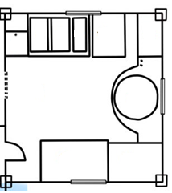

See plant layout page for the description.
The only machine on the production area maybe is where the ingredients will be cooked. The utensils like cups, spoons, seiver and other tools for making polvoron can be buy at the local markets. The cooking area can able to load at capacity of 10kg of its ingredients and there is a scale in the top or in the wall above the cooking area to determine if the ingredients are at its max capacity limit. The floor plan is design for making polvoron for fast production and it is segmented to its arrangement from ingredients to cooking and to packaging.

- Plant Locations

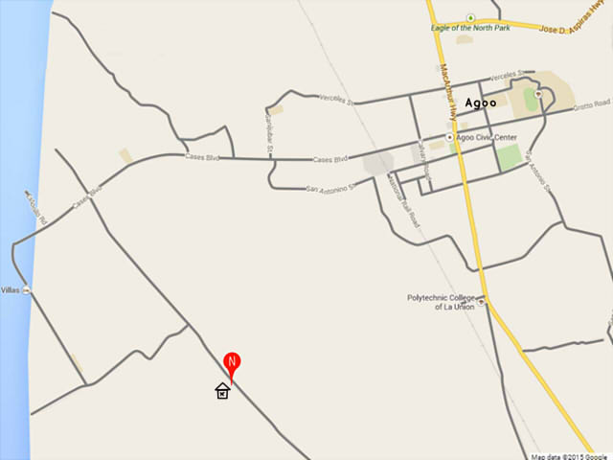

Agoo La Union Map according to Google Map.

The NutriMilky Company location is at the red mark as shown on the map above.

The NutriMilky Company is simply located at brgy. Purok Agoo La Union, near in the Kullapo Motor and Welding Shop and beside of sector 4 no. 10 house. It is located there because of the land owners are also staffs of the company, so that they just used the vacant area there. The area are pullution and noise free, and the wind gusts help the area refreshing by the help of the plants and trees.
The NutriMilky suppliers are slightly close to our location because the main ingredient we use like flour is in InterFlour Company and it is only located in Zambales and you can travel there with your private vehicle in just 3 hours and 30 minutes. Other ingredients suppliers are also near to us and some of it can buy at the public and local markets.

- Plant Layout

Ground Floor Plan
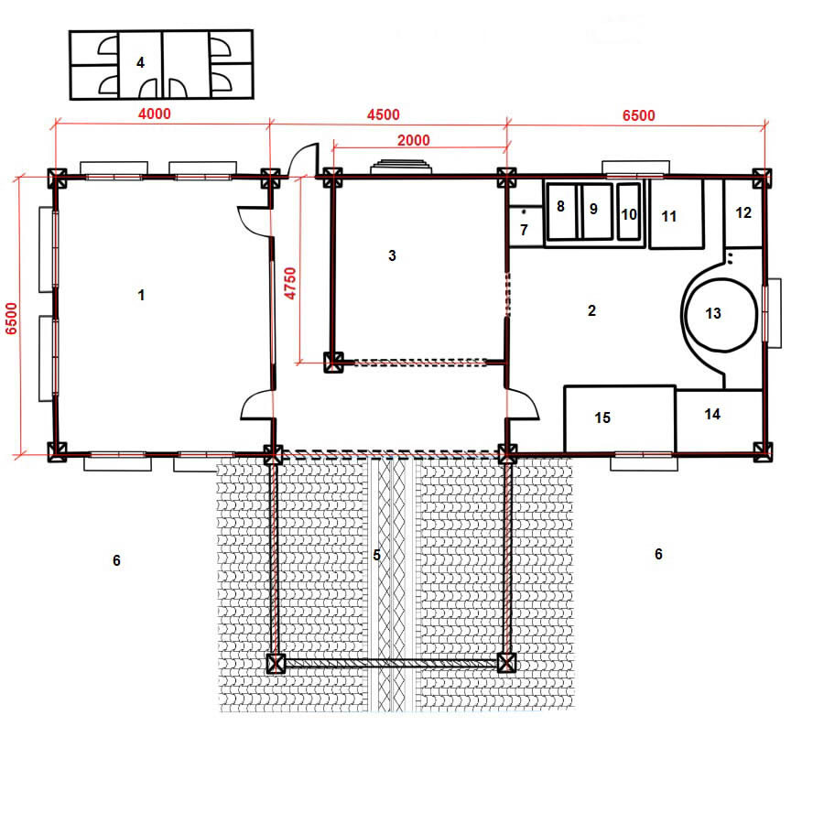

1- Company Office 10 – Butters
2 – Production Area 11 – Flours
3 – Stock Room 12 – Sifting/Filtering of Flours
4 – Comfort Room 13 – Cooking Area
5 – Front/Guard House 14 – Cooling/Mixing Area
6 – Parking Area 15 – Wrapping/Packaging
7 – Faucet for Hand Washing
8 – Sugars
9 – Powdered Milks

Front view/ perspective picture

- Building and Facilities

The Building of the NutriMilky Company is a one storey building and its land area is about 30square meter. The building has 12 beams with 1x1ft wide. The wall concrete hollow blocks used is 5inch (“5CHB) because the building is built with a steel deck so that any disaster and earthquakes comes the building is indestructible and to avoid damaging the equipments inside of the building. The tiles of the floors are granites so that it won’t break immediately whenever heavy of the equipments and tools.

- Raw Materials

A raw material to be use in the company like flour is ordered to InterFlour Company and they are producing 1000 MT per day. The Philippines is producing 2 million MT a year and 90% of it is controlled by existing local millers. But the new players at this production of flour have setting an expected amount of 2000MT per day. The flours of InterFlour are selling at a steady higher price of P870 to P880 per bag or a P50 difference per bag than the new players.

Powdered milk in making polvoron is depending on the taste of the powdered milk and depending on how they affect the taste of our polvoron but any of the two can give calcium. We can choose any one of the two powdered milk producers like Nido or Bearbrand with the prize of P1200 plus for 2.5kg of them depending on what powdered milk to be used.

We are not concerned by needing a sugar for our ingredients because there is a six large sugar mills here in Luzon especially in the tarlac and they are delivering trucks of sugars here in northern Luzon markets. The average mill site prices of raw sugar have also risen slightly every month or a year, from an average of P1,646 per 50-kilogram bag.

Large dairy products especially butter are delivered here in Luzon markets. There are 40,322 heads that produce milk or dairy products in Philippines like cattle. carabao and goat, and around 25% of their milk is created in a butter products. Some of the companies are delivering dairy products like cheese, butter and margarines here in Luzon by contacting them. The companies are Dpo Philippines Incorporated, Estrima Int.Corp. and Fargo.

The flavourings we use in making polvoron can also buy at the local and public market and also many truck deliveries here in northern Luzon. Chocolate or cocoa to be used in coating the polvoron is rarely used because it is for pulling customers and watching if it is effectively on the market. And there is many malunggay here around the company location and we are also willing to plant malunggay trees along the roads for the benefit of the barangay.

The payment we use is simply direct payment or cash. If they offer us a contract we ensure that they will give us discount or any extra good services to accept it so that we can help them for their business and they help us also in our business.

- Utilities

The electricity that supports our company is LUELCO since they are supporting the electric power here in La Union. We don’t problem water sources in company because the land area that the company built has a well and can supply water all the day because the area is in the lowland and pretty close to the sea.

- Waste Disposal

In waste disposal of the company there is approximately 1 to 2 garbage bag per week, because the only trash to be disposed is small plastics and there is a weekly garbage collector truck here in Agoo. The sacks of flours and sugars will be sell or donated in the rice mills because rice mills are in needing sacks for the rice’s they milled. Maybe some of our products used a cardboard (karton) for their packaging we can also sell them at the junkshops so that there is extra income of the company. The biodegradable wastes of the company can be buried at the disposal pit located at the backyard of the company. The canals, drainage and water disposal of the company are also located at the backyard of the company.

- Producting Cost
The wages of the workers in making polvoron is P10,000.00 per month for a starting business whether the business gained profit or not. Managers, supervisors, and other staffs of the company office can get a higher wages. If the NutriMilky earned good sales and become large producing polvoron and other traditional delicacies in the market the wages will be change into another form. For example, if the company sales earned 1 million in a month the 25% of it is for the workers and staffs, the 30% is for the supplies or ingredients to be used, 10% of it is for utilities, 5% is for the company business license and other bills, 20% for the company earns, 5% for charities donations and other environmental projects and 5% for food and drinks.

- Financial Feasibility

- For Existing Projects

The land area, some equipments of the company is owned by the manager or CEO of the company.

Assets
Cash | P500,000.00
Long or Short Term Investments | Depends on how the company gamble for bigger return to the company
Accounts Receivable | It depends also on how many debtors and their liabilities to the company.
Prepaid Rent | N/A
Land Area | P2,000,000.00
Building | P750,000,00
Machinery and Equipments | P300,000.00

- For new Projects
Total Project Cost
Land | N/A
Building | P750,000.00
Labor | P750,000.00
Machinery and Equipments | P300,000.00
Utilities | P30,000.00
Ingredients | P71,934.00
Building Permit | P20,000.00
Total | P1,921,934.00

- Contributions to the Philippine Economy

The Nutrimilky Company is helping our governments to provide and promoting the Filipino delicacies. Feeding program on a poor barangays and Department of Social Welfare and Developments are one of the monthly activities of a company to promote our product and also to provide nutritious foods to them.

We are also helping places that are lack of trees especially malungay trees because one of our main products is containing a malungay and to promote healthy foods and vitamins.

